Thomas Project Page

- Content:
- Main Page:
Player Colors in Goldsrc Multiplayer
If you’ve played any of the multiplayer games that use Valve Software’s Goldsrc engine, you may be familiar with the customization options available. These can allow you to personalize your character's appearance, changing the model and color of your character. One day, as I tend to do, I wondered if I could recreate the colors of the character I had personalized in other 3D software, such as Blender. This led me to the question: How the heck does the game actually change the colors of a character? And so the effort of my understanding has been put here, so the next hopeless chap may escape the same fate I did. Or just to be interesting.
First, let’s start off with how the color change looks in these games. I will be using Half Life for demonstration purposes, but most of Valve’s games in the Goldsrc engine use the same system, including Team Fortress Classic and Deathmatch Classic. But basically, a user is given 2 sliders that will change the color of your character, Primary and Secondary.
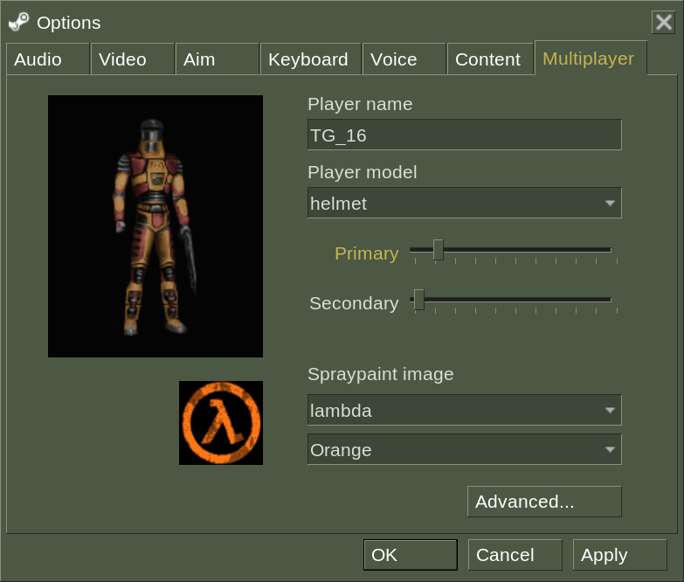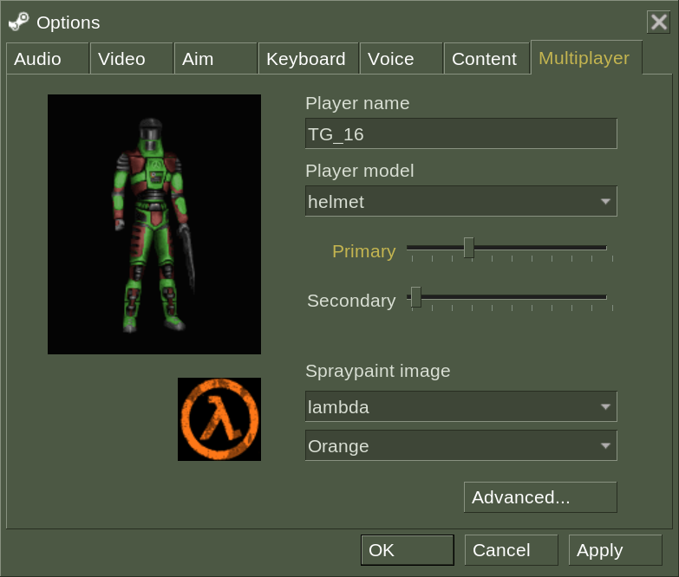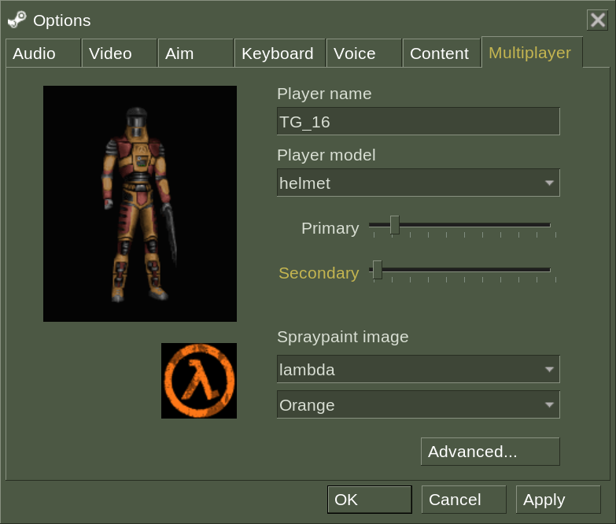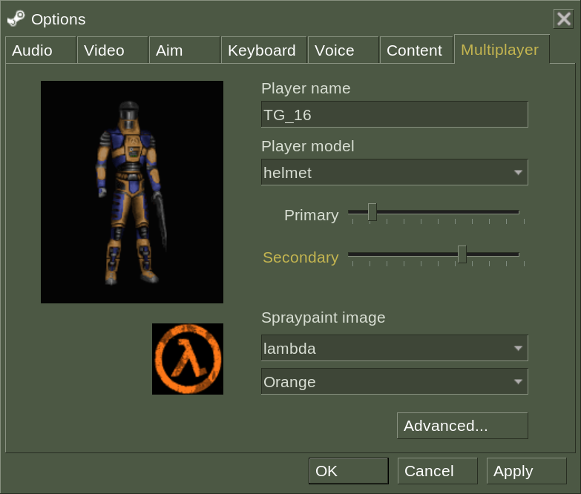
These sliders change the internal variables “topcolor” and “bottomcolor” respectively. These values can range from 0 to 255 (this will be a problem later). What these variables actually do is change the hue, and only the hue, of certain colors on the texture of the model. You see, the texture file is a .bmp file, an image file that uses a pallet to set the colors of the image. Each pixel is assigned a position on this pallet, and so changing the pallet will change the colors of the image. This is usually done to reduce the size of an image file, but Goldsrc uses this to easily change to colors of textures. This is what the pallet of the default character in Half Life multiplayer, helmet, looks like:
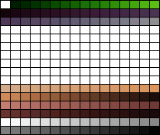
topcolor edits the hue of these colors:
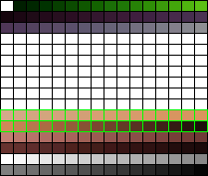
…and bottomcolor edits the hue of these colors:
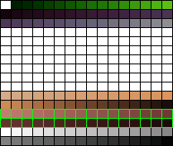
As you might be able to tell, these only cover a small portion of the full colors of the textures, this is how Goldsrc only edits one part of an image!

Now, this is all well and good, but there are a few complications if we want our textures to look correct in another program. We could go in and edit the hue of all of the pallet slots attached to the color we want to change, but most image editing software store hues up to 360, not 255. This makes it really hard to get the exact right copy of the color we want. Thankfully, someone has already done the work for us. I believe there are a few programs that can do this, but I happen to be familiar with Half Life Asset Manager. HLAM mainly allows you to look at Goldsrc models, but it also has a full recreation of the multiplayer coloring system. After installing HLAM, open the model of your choice with it. I will be using the default helmet model again, located in your Half Life install (Half-Life/valve/models/player/helmet/helmet.mdl). After you open your file, navigate to the “Textures” tab at the bottom.
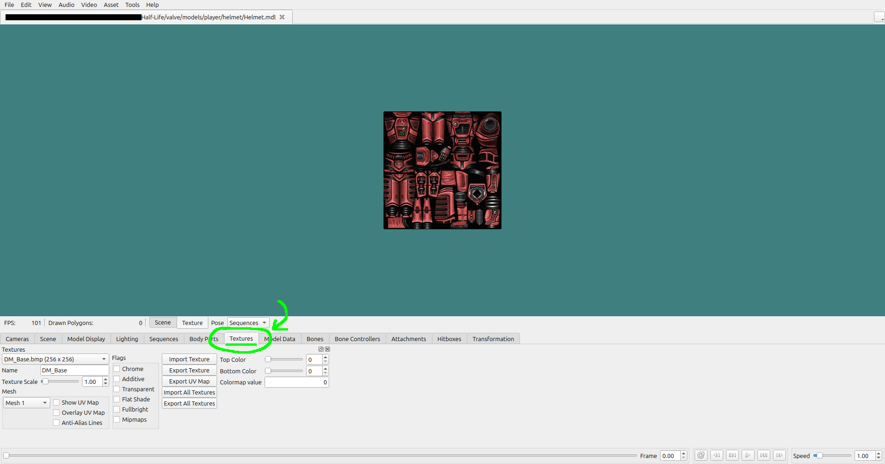
If the model you chose supports recoloring, the texture should look red. If it doesn't, check the drop-down menu on the bottom left labeled “Textures”, and see if other texture files work, as some of them may not change colors. Now, you can mess around with the “Top Color” and “Bottom Color” sliders to set them to the colors you want. I will set them to the default colors, topcolor of 30, and bottomcolor of 6.
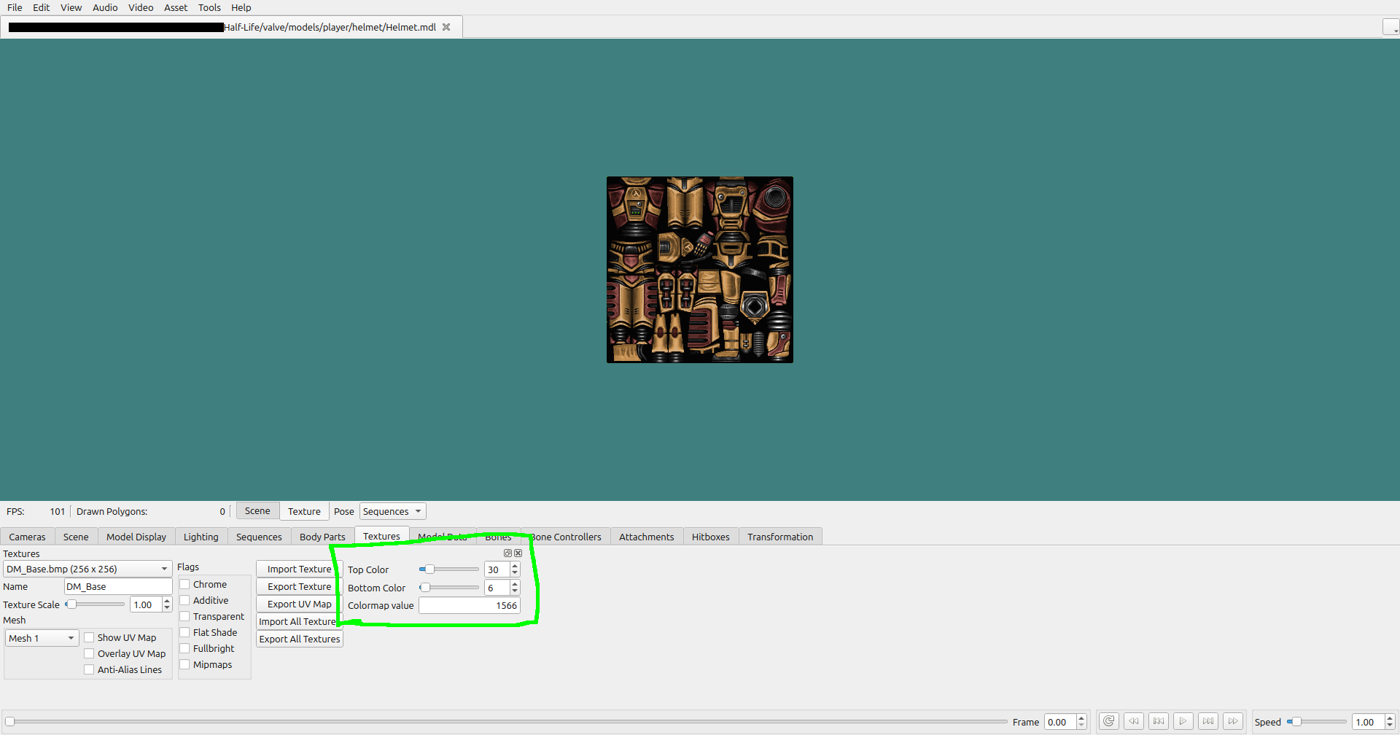
Now you have your properly colored image! All you need to do now is take a screenshot of the texture, either using your operating system’s built-in screenshot tools, or you can click on “Video” -> “Take Screenshot…” in the top right of HLAM. Make sure the “Texture Scale” on the bottom left is set to 1, otherwise your image will be too big. After you’ve taken your screenshot, crop the image to only contain the texture. You should end up with something like this:
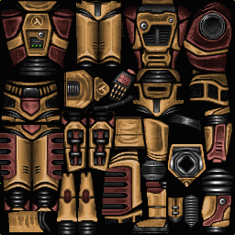
This is really the end of most of our work. If you want to use these colors in a different program, simply swap out the original texture with your colored one. The exact process for this is different for every program, but I will quickly show you how to do it in Blender. I should note that I am in no way a Blender expert, nor am I even a competent Blender user, but I know how to do this specific thing. First, import helmet.mdl (or the model of your choice) to Blender using SourceIO. Then navigate to the “Texture Paint” tab. Click on “Image” -> “Open…” like so:
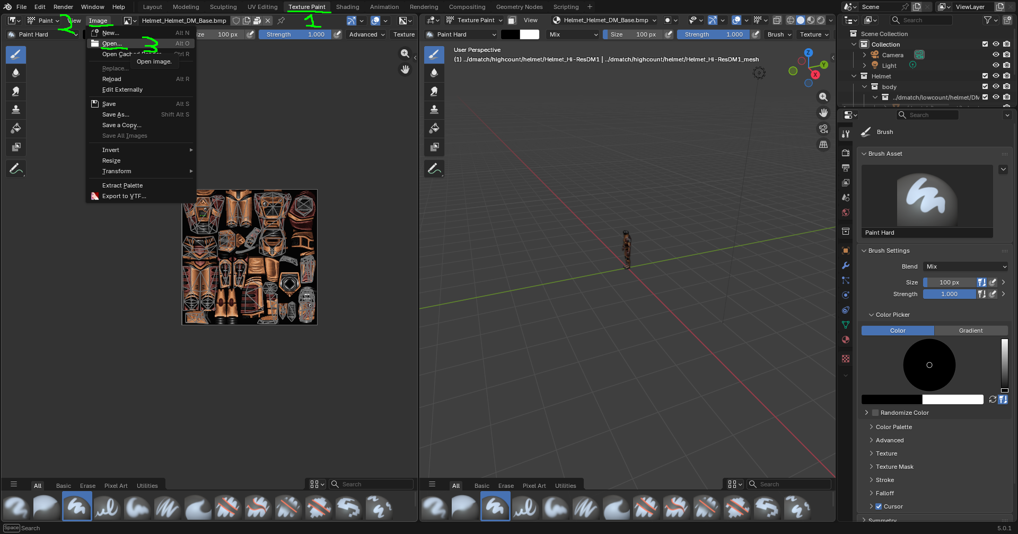
Open your colored image. This will import the image into Blender. Next, navigate to the “Shading” tab. At the bottom, there should be a node labeled “$basetexture”. Click on the image dropdown and select your imported image.
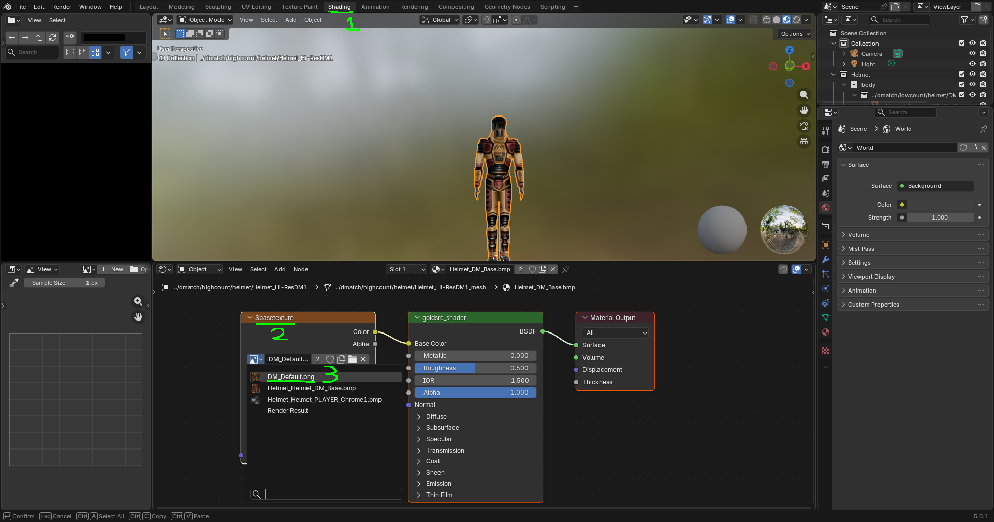
And there you go! Your model is properly recolored. Now go make something cool!


- Child Page: Team Fortress Classic
Team Fortress Classic
A quick side section relating to Team Fortress Classic. If you’ve played Team Fortress 2, you may be familiar with how that game handles team colors, which is to say, TF2 uses separate textures for its different teams. TFC does not do this, and instead uses preset colors for every team that it applies using the topcolor and bottomcolor system. For convenience, I will provide all of the different colors here on this page. However, I should note that the colors used change depending on if you are using the new or old models. If using the old models, every class shares the same color for each team. But if you use the new models, each class has a unique color for each team. Civilian only has old models, so he will always use the old model colors.

Old Model Colors (Same for Every Class)
 | Blue Team | Red Team | Yellow Team | Green Team
topcolor | 150 | 250 | 45 | 100
bottomcolor | 140 | 240 | 35 | 90

New Model Colors (Different for Each Class)

Scout | Blue Team | Red Team | Yellow Team | Green Team
topcolor | 153 | 255 | 45 | 100
bottomcolor | 139 | 10 | 35 | 90

Sniper | Blue Team | Red Team | Yellow Team | Green Team
topcolor | 153 | 255 | 45 | 80
bottomcolor | 145 | 10 | 35 | 90

Soldier | Blue Team | Red Team | Yellow Team | Green Team
topcolor | 153 | 250 | 45 | 100
bottomcolor | 130 | 28 | 35 | 40

Demoman | Blue Team | Red Team | Yellow Team | Green Team
topcolor | 153 | 255 | 45 | 100
bottomcolor | 145 | 20 | 35 | 90

Medic | Blue Team | Red Team | Yellow Team | Green Team
topcolor | 153 | 255 | 45 | 100
bottomcolor | 140 | 250 | 35 | 90

HWGuy | Blue Team | Red Team | Yellow Team | Green Team
topcolor | 148 | 255 | 45 | 100
bottomcolor | 138 | 25 | 40 | 90

Pyro | Blue Team | Red Team | Yellow Team | Green Team
topcolor | 140 | 250 | 45 | 100
bottomcolor | 145 | 25 | 35 | 50

Spy | Blue Team | Red Team | Yellow Team | Green Team
topcolor | 145 | 250 | 45 | 100
bottomcolor | 150 | 240 | 35 | 90

Engineer | Blue Team | Red Team | Yellow Team | Green Team
topcolor | 140 | 5 | 45 | 100
bottomcolor | 148 | 250 | 45 | 90

- Child Page: Character Preview
Character Preview
When creating a custom character in Goldsrc, there is a preview image shown in the menu to allow you to see what your character will look like. These images are produced using the same method as the character textures, but getting your hands on the remapped texture is much easier. In fact, Goldsrc will do it for you. After you have saved your character, exit the game and navigate to your game install folder. Depending on the game, you will then need to go into a game specific folder. Half-Life is /valve, Opposing Force is /gearbox, Team Fortress is /tfc, Deathmatch Classic is /dmc, and so on. Then go to models/player, remapped.bmp is the file you’re looking for.
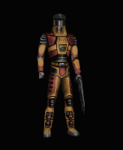
You also can find your colored spray in your game folder, under /logos. The spray will be named remapped.bmp.


- Wireframe:
The style of every page will be the same, the only difference being the content.
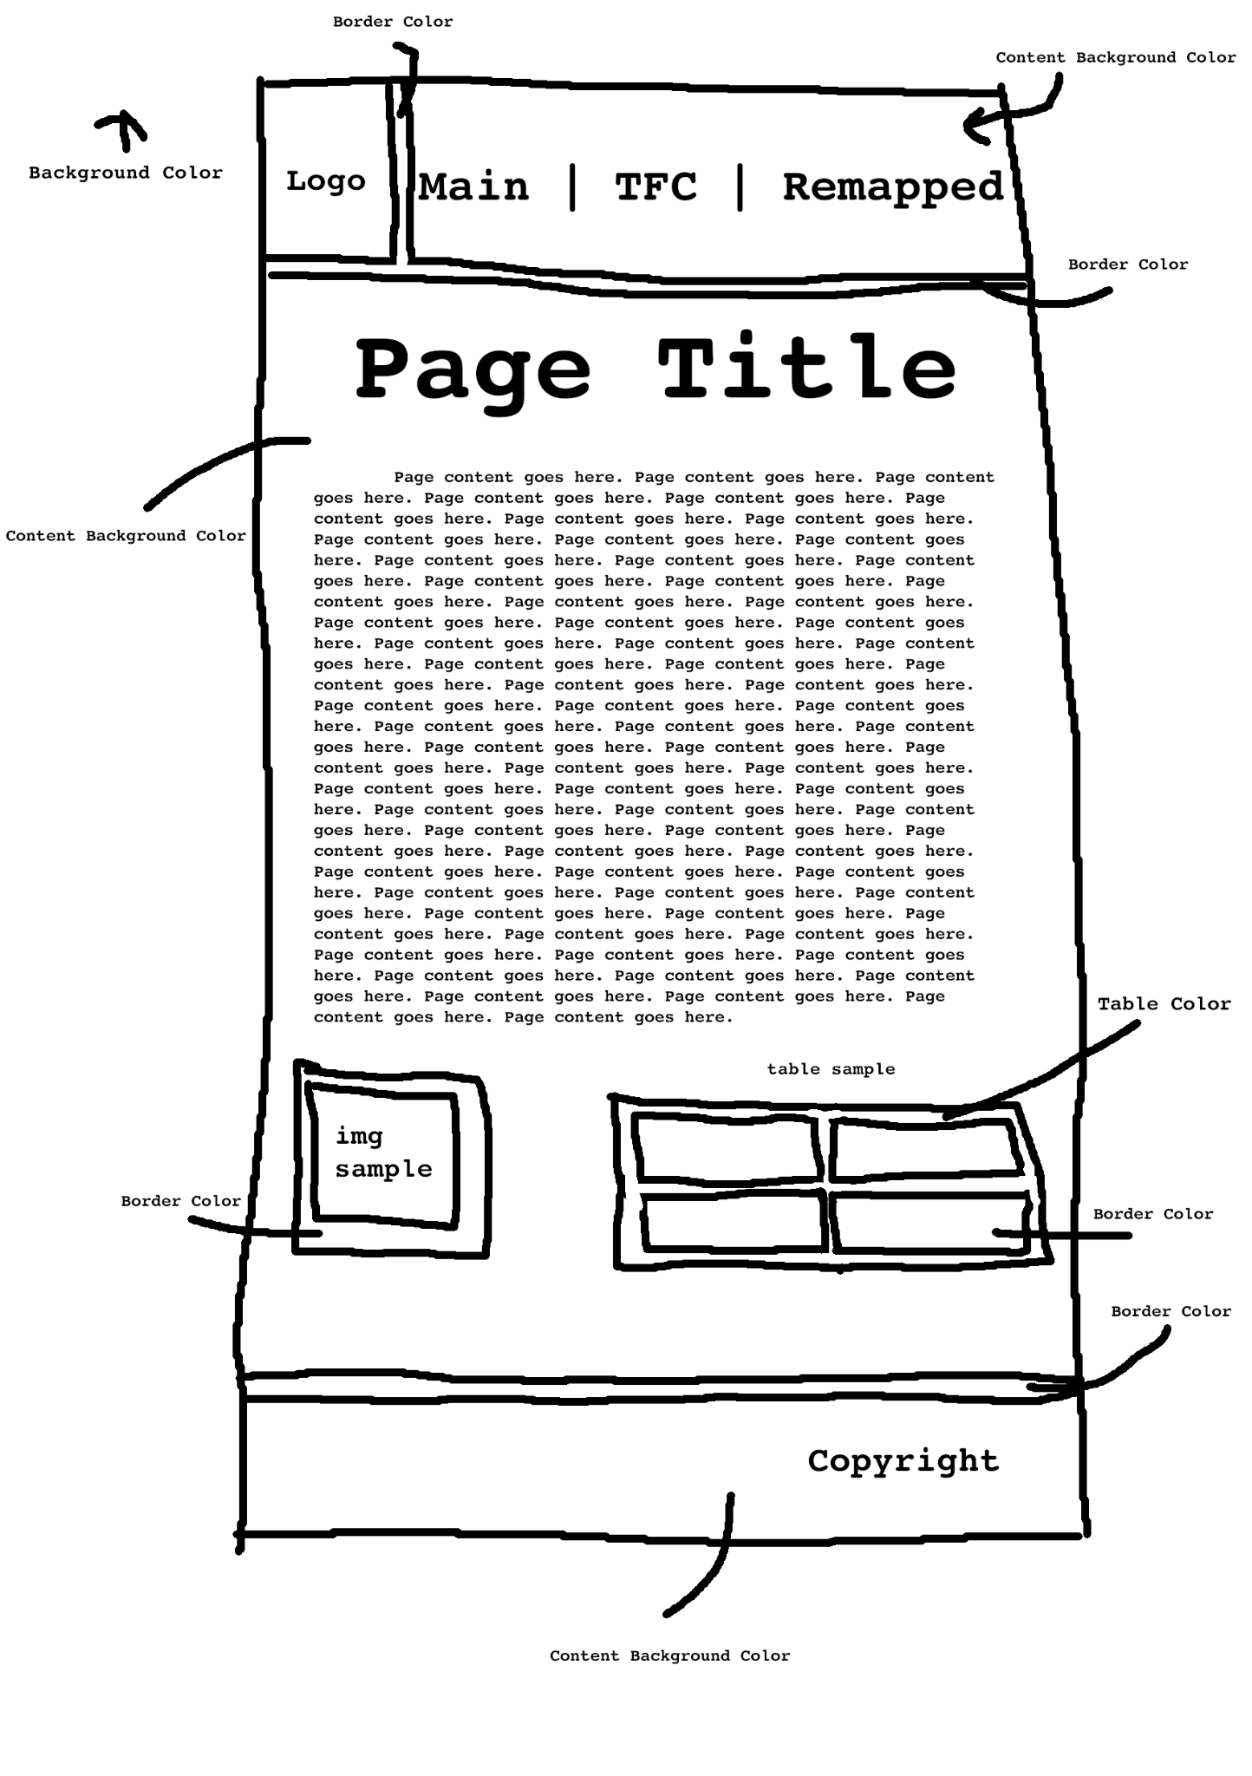

- Purpose:
The purpose of this webpage is to inform people how to recreate the coloring effect used in Goldsrc games in other 3D software.

- Audience:
This webpage is intended to be viewed by people who want to fully recreate custom characters or assets from Goldsrc games in other 3D software.

- Logo:
- Page Logo
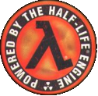
- Tab Logo

- Colors:

Heading Text: #c4b550
Paragraph Text: #ffffff

Page Background: #000000 | Content Background: #4c5844
Border: #889180 | Table: #3e4637

- Font:
Heading Font: Trebuchet Bold
Paragraph Font: Veranda

